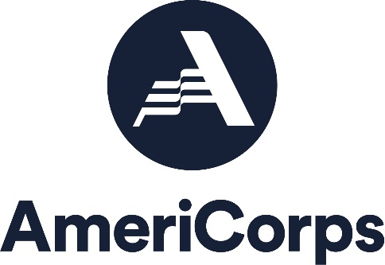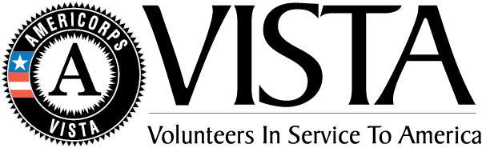
The Plantory Network
2021-2022 AmeriCorps VISTA Program Application

VISTA Project Title:
Address where VISTA will serve

Organization Name |  | Address:
Host Site Tax ID/EIN # |  | City, State, Zip Code
Site Supervisor |  | Title
Email |  | Phone #

Total number of AmeriCorps VISTA member requesting: _________

By signing below, we understand that:
- We are required to provide a cost share of $6,000 thirty day prior to our VISTA members start date. We will be paying by the following: ___ Electrically Deposit ___ Organization check
- Our institution is responsible for covering expenses (such as supervision, service-related travel, site-specific training, site-specific background checks, at least $150.00 for AmeriCorps VISTA member professional development, phone, office supplies, business cards, etc.) above the required cost share.
We are submitting the following:
- Completed Proposal Cover Page
- Completed application and narrative
- Acknowledge of the AmeriCorps Prohibited Activities
- VISTA Assignment Description (VAD)
- AmeriCorps VISTA Member Position Description
- Organizational Capacity Checklist

_________________________________________________________________________________
Supervisor Name Signature Date

_________________________________________________________________________________
Authorized Representative Name Title

_________________________________________________________________________________
Authorized Representative Signature Date

Institution/Organization Name:

Has your institution/organization ever hosted a Campus Compact AmeriCorps VISTA?
- Yes
- No

Institution/organization type
- Nonprofit Organization
- K-12 School project

EIN Number

Mailing Address

City, State,

Zip Code (Must include 4-digit code extension)

Host Site Contact Informaton:

Host Supervisor Name

Host Supervisor Title

Host Supervisor Phone #

Host Supervisor Email

Will this person have full or part-time responsibility for supervision?
- Full time responsibility
- Part time responsibility

Is there an additional person who will be supervising the VISTA?
- Yes
- No

Who is the primary contact with the authority to commit funds on behalf of the applicant?

___________________________________________________________________________

Budget Authority Phone

Budget Authority Email

Project Information:

VISTA Project Year
- Year 1
- Year 2
- Year 3
- Request beyond year 3

Project Focus Area: Please Select One
- Economic Opportunity: financial literacy, housing, job readiness and access
- Education: K-12 readiness & success, post-secondary readiness and success
- Healthy Futures: nutritious food access & education, access to health care
- Veterans and Military Families

Narrative Section

- Opportunity listing

This abstract is a promotional pitch for your project. Please give a summary of your proposed project and the VISTA’s role within the project, including the general tasks and activities the VISTA will perform in order to implement the proposed project. Include how the selected Project Focus Area will impact the community and fulfill the anti-poverty goals of the AmeriCorps VISTA program. If your potential project is accepted, the abstract is used to market your positions, so you are encouraged to make it compelling and memorable.

- Community Need Statement
Describe the unmet poverty-related need(s) that this project addresses, emphasizing statistical data and citing reliable sources. Clearly describe which populations the project will serve, why the needs are not currently being met, and how the planned program strategy will ultimately strengthen the community. Include any evidence that suggests your approach will be successful. Include evidence of past performance, results from credible research, or results from a similar, successful program. Evidence will provide the basis for decisions about the design, frequency, and intensity of the proposed intervention.

- Partnership- Year 1 projects only
Describe your community partner’s role in designing this project proposal. Describe the history, strengths and assets that exist in the partnership. Explain how there will be a balance of power among partners enabling resources to be shared in the scope of the VISTA project.

- Strengthening Communities: Goals and Outcomes
Describe VISTA activities and results. Cleary explain how leveraging a Plantory AmeriCorps VISTA will result in increased capacity to meet unmet needs.

- Strengthening Communities: Continuous Improvement Plan and Sustainability

Please address the following elements: 1) how will your approach for impact change over time as the work-plan is implemented; 2) what process will be used to identify progress and make changes as needed; 3) plan for long-term sustainability of the partnership.

- Strengthening Communities: Campus Connections and Alignment

Please address the following elements: 1) how does the proposed VISTA project align with existing community initiatives or Civic Action Plan (if completed); 2) If this proposal is being initiated by a department that is not located within the existing civic engagement/service programs on campus, describe how you will share information and collaborate with the current campus community engagement efforts.

Capacity Building
Capacity Building and Leverage

Please select relevant outputs.
G3-3.4: Number of organizations that received capacity building services
G3-3.1A: Number of community volunteers recruited or managed
G3-3.16A: Dollar value of cash or in-kind resources leveraged

Capacity Building & Leverage Interventions (choose at least one)
Volunteer management training
Resource development
Systems development
Donations management

Outcomes (choose at least one)

Please select relevant outcomes.
G3-3.10A: Number of organizations that increase their efficiency, effectiveness, and/or program reach

Economic Opportunity
Economic Opportunity
Please select relevant outputs.
Financial Literacy O1A: Number of individuals served
Housing O1A: Number of individuals served
Housing O4: Number of units developed or repaired
Employment O1A: Number of individuals served
Employment outcomes
Please select relevant outcomes
O10: Number of individuals who secure employment
O21: Number of individuals with improved job readiness
Employment interventions
Please select relevant interventions
Job training
Job placement
GED education
Other adult education
Financial literacy outcomes
Select relevant outcomes
O9: Number of individuals with improved financial knowledge
O19A: Dollar value of tax returns generated
Financial literacy interventions
Please select relevant interventions
Financial literacy education
Financial fraud prevention
Tax preparation

Education

Please select relevant outputs.
School Readiness ED1A: Number of individuals served
K-12 Success ED1A: Number of individuals served
Post-HS Education Support ED1A: Number of individuals served

K-12 success interventions
Please select relevant interventions
ED5A: Number of students with improved academic performance
ED9: Number of students graduating from high school on time
ED10: Number of students enrolling in post-secondary education/training
ED27C: Number of students with improved academic engagement or social-emotional skills
ED6: Number of students with increased attendance
ED7A: Number of students with decreased disciplinary incidents

Post-HS education support outcome

Please select relevant outcomes
ED11: Number of individuals earning a post-secondary degree or technical certification
School readiness outcome
Please select relevant outcomes
ED23A: Number of children demonstrating gains in school readiness

Post-HS education support interventions
Please select relevant interventions
Tutoring
Mentoring
Family involvement
Service-learning
Summer learning
School readiness interventions
Please select relevant interventions
Tutoring
Mentoring
Other classroom
Support out-of-school time
Family involvement
Service-learning
Summer learning
Classroom teaching
Social and emotional support

Healthy Futures
Healthy Futures
Please select relevant outputs.
Obesity and Food H4A: Number of individuals served
Obesity and Food H10A: Number of pounds of food provided
Access to Care H4A: Number of individuals served
Access to Care interventions
Please select relevant interventions
Outreach
Education/Training
Referrals
Medical Services
Counseling/Coaching
Opioid/Drug Intervention
Disability Inclusion
Food security interventions
Please select relevant interventions
Outreach
Education/Training
Referrals
Medical Services
Nutrition/Food Support
Physical Activities
Counseling/Coaching
Opioid/Drug Intervention

Assessment
Assessment Plan
Describe your plans for assessing progress toward achieving your selected project projected outputs and outcomes. Include details regarding measurement tools to be used (e.g., surveys, databases, etc.) data tracking, collection and aggregation. If applicable include a description of how you will work with partners to collect data and collectively assess impact

